DONATE NOW AND DOUBLE YOUR MONEY

A generous supporter will match donations made between during a 60-day period (18 April – 7 June 2017) up to a total of $20, 000. Donate now to make an especially effective contribution to lawyers and other human rights defenders at risk by supporting LRWC’s international law research and education. Your donation will support research and education about international human rights law of critical concern to advocates at risk. Projects supported will include:
- ILLEGITIMATE CHARGES & NOTICE - A new guide examining international law standards for the legitimacy of criminal charges and notice requirements, inspired by increasing state use of criminal law systems to arbitrarily arrest, prosecute and punish critics and their lawyers. Thousands of advocates worldwide are affected by such prosecutions, often impossible to defend under domestic laws.
- UPDATES to existing publications on international rights to:
- Pre-trial Release and Presumption of Innocence;
- Freedom from incommunicado and secret detention;
- Rights to Fair Trial and Access to Counsel.
LRWC international human rights law publications empower advocates to uphold rights and remedy violations. Visit the LRWC website (www.lrwc.org) for more information about the significant work being done by LRWC members. Click on LIBRARY to review publications and VIDEO to watch videos.
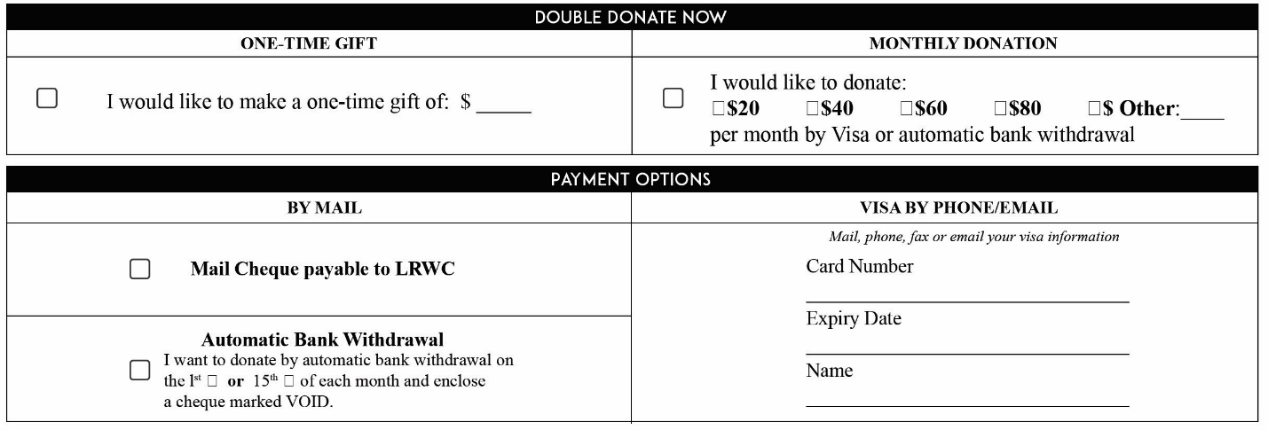

Donate online
Donate with Canada Helps
Donate with PayPal
Donate with Interac e-transfer
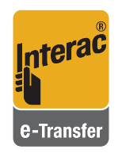
LRWC work is exceptional thanks to the pro bono work of members, the support of donors and cooperation with NGOs around the world. LRWC reports, letters and briefs have been produced in English, French, Khmer, Spanish, Arabic, Turkish, Vietnamese and Thai. Your contribution goes a very long way to protecting protectors around the world.
“Thank You. Without LRWC we would be alone and without hope”,
say victims and families.

