NGO in Special Consultative Status with the Economic and Social Council of the United Nations
www.lrwc.org; lrwc@portal.ca; Tel: +1 604 738 0338; Fax: +1 604 736 1175
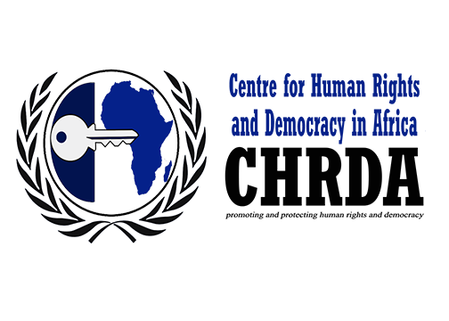
3220 West 13th Avenue, Vancouver, B.C. CANADA V6K 2V5
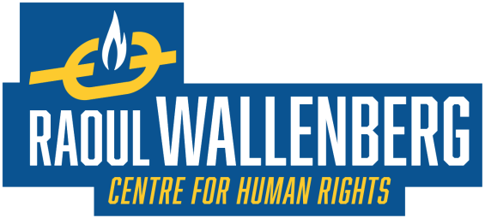

Rights groups seek UN intervention to end Cameroon atrocities

Immediate release

26 August 2019 – Lawyers’ Rights Watch Canada (LRWC), supported by the Centre for Human Rights and Democracy in Africa (CHRDA) and the Raoul Wallenberg Centre for Human Rights (RWCHR), has submitted a statement to the 42nd Session of the United Nations Human Rights Council seeking an end to catastrophic atrocities taking place in the Northwest and Southwest regions of Cameroon.

Since October 2016, Anglophones in Cameroon have been the target of extreme violence and persecution by the Cameroon government. There is evidence of human rights violations that amount to crimes against humanity. A separatist movement has responded with violent acts against the State’s defence forces. Government officials and armed insurgency groups have reportedly perpetrated sexual assault, torture, and public humiliation of women and girls throughout Anglophone regions.

Other reported crimes against humanity in the Anglophone regions include murder and lethal force against civilian populations, mass arbitrary arrests and detentions, torture of persons in State custody, and deportation and forcible transfer of Anglophone populations.

To date, approximately 500,000 civilians have been forcibly displaced. Many internally displaced persons have relocated to remote bush areas with inadequate access to food, potable water, clothing, basic hygiene, or medical assistance for resulting diseases, including dysentery and malaria.

“Cameroon is now one of the largest sources of displaced persons in the world,” explained Pearl Eliadis, Senior Fellow at the RWCHR and co-author of the report ‘Cameroon’s Unfolding Catastrophe: Evidence of Human Rights Violations and Crimes Against Humanity.’ “The international community needs to work in solidarity to resolve this human rights crisis.”

“The gross human rights violations against unarmed civilians in the Anglophone Regions are horrendous,” added Felix Agbor Nkongho, Chair of the CHRDA and co-author of Cameroon’s Unfolding Catastrophe. “There must be accountability for these egregious crimes,” urged Nkongho, a lawyer who was himself arbitrarily detained by Cameroon authorities from January to August 2017.

“LRWC’s statement is an urgent call to the international community to act now to end atrocities that are clearly identified as crimes against humanity in the report, Cameroon’s Unfolding Catastrophe,” said Robert Lapper, QC, a Professor in the Faculties of Law and Human and Social Development at the University of Victoria, Canada, and a Director of LRWC.

The urgency was underscored by report co-author Yonah Diamond, Legal Counsel to the RWCHR. “The crisis in the Anglophone regions of Cameroon is the most neglected in the world and increasingly neglected from within as journalists fear for their lives,” he noted. “The need for coordinated international action to address evidence of crimes against humanity and prevent further mass atrocities is more urgent than ever.”

LWRC has submitted its statement to the Human Rights Council to urge Cameroon to end the violence, provide humanitarian assistance to those in need, and ensure effective and impartial investigations and remediation of all violations of human rights. LWRC has also asked the Human Rights Council to launch an independent international investigation into the grave and widespread human rights violations by the government of Cameroon and non-state actors against civilian populations and to urge the Secretary General and the Security Council to ensure international and all-inclusive domestic dialogue towards peaceful resolution of the crisis. The Council meets in Geneva from 9 to 27 September 2019.

To view the statement please go to: https://www.lrwc.org/human-rights-catastrophe-in-cameroon-written-statement-to-the-42nd-session-of-the-un-human-rights-council/.

For further information please contact:

Felix Agbor Nkongho, Chair, Centre for Human Rights and Democracy in Africa (CHRDA): Tel: (+237) 679-821-499; email: nkongho@chrda.org.

Pearl Eliadis, Senior Fellow, Raoul Wallenberg Centre for Human Rights (RWCHR), Montreal: Tel: (+1) 514-771-9462; email: eliadis@rights-law.net.

Yonah Diamond, Legal Counsel, Raoul Wallenberg Centre for Human Rights (RWCHR): Tel: (+1) 917-391-9915; email: jonahdiamond@rwchr.org.

Catherine Morris, UN Liaison Director, Lawyers’ Rights Watch Canada (LRWC): Tel: (+1) 250- 477-0129; email: research@lrwc.org.

This press release is also found at: https://www.lrwc.org/cameroon-rights-groups-seek-un-intervention-to-end-cameroon-atrocities-press-release/.

